SORTING AND DETAIL ORIENTATED GAMES
Materials:
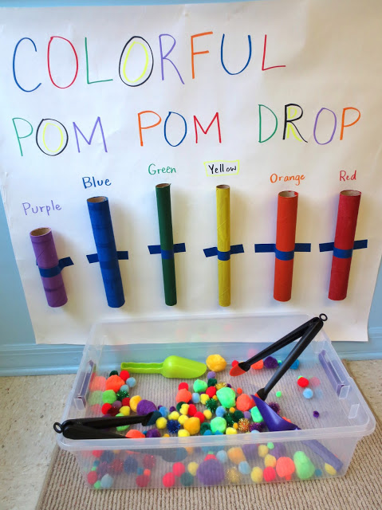
- Different width painted cardboard tubes
- Strong tape
- Large A2 paper or Whiteboard
- Selection of POM POMS
- Plastic tongs/spoons
Method:
Attach the tubes to the paper or white board and label with either words or pictures.
Encourage person to pick up the pom poms with the tongs (encouraging hand eye coordination and fine hand movements) and place in the correct coloured tube.
This will also stimulate both sides of the brain and be a focusing and balancing task, as well as stimulating visual and tactile senses.

