Making Melted Crayon Art

By the Team at 287 Dyke Rd, Brighton

This is an easy straightforward project that delivers a lot of graphic impact for not very much effort.

You will need:
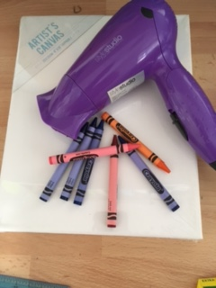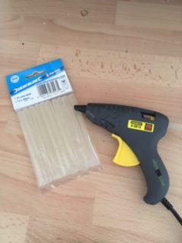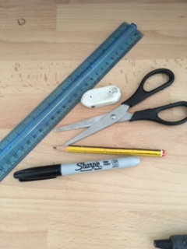
- A blank canvas the size of your choice. (You can buy them in the pound shop)
- A hair dryer
- Coloured crayons, (the amount depends on the size canvas you have chosen
- Drawing materials
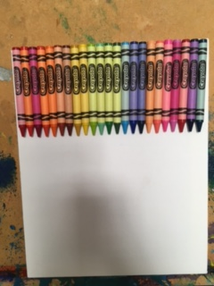
Method:

- Preparing your canvas

It’s up to you how you arrange the crayons; you can either leave the wrappers on or remove them but it can be quite effective to leave them on.
Using the glue gun, stick the crayons onto the canvas. This should be done by support staff or under very strict supervision as the glue is very hot and can burn if you get it on your skin

- Before melting the crayons, make sure that you have covered the surrounding area with newspaper as it can be quite messy. If possible, it is better to have the canvas standing up at a tilt so that the wax can run down. Hold the hairdryer quite close to the crayons and turn it on. It only takes a minute for the crayons to start melting

- To make you work of art more effective, (although not necessary) you can make silhouettes of your choice.

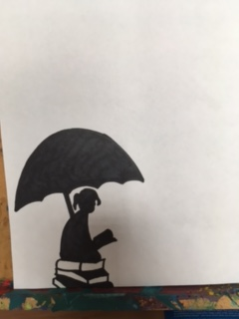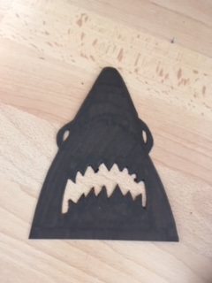

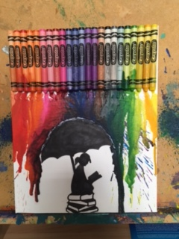
To make an umbrella effect, glue your silhouette onto the canvas before melting the crayons.
Using a piece of card (cut to the right length) fold down the middle and then make lots of slits up to the middle line so that it can bend around the shape of the umbrella.

Stick into place using sellotape

Once the wax has dried, you can remove the guard, Very effective!!
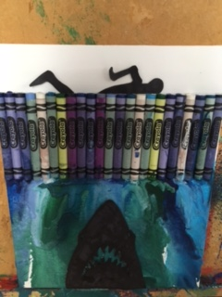

Depending on what you would like to do, you could also prepare a silhouette and place on top of the melted crayons also very effective!!

