Make an origami frog that really jumps!

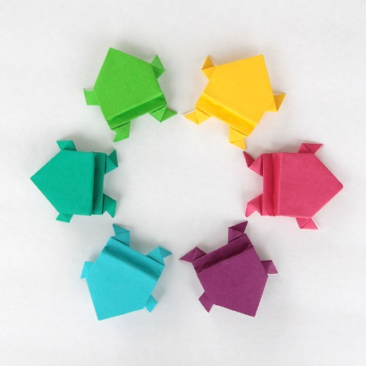
Find a piece of square paper and then fold on the dotted line:
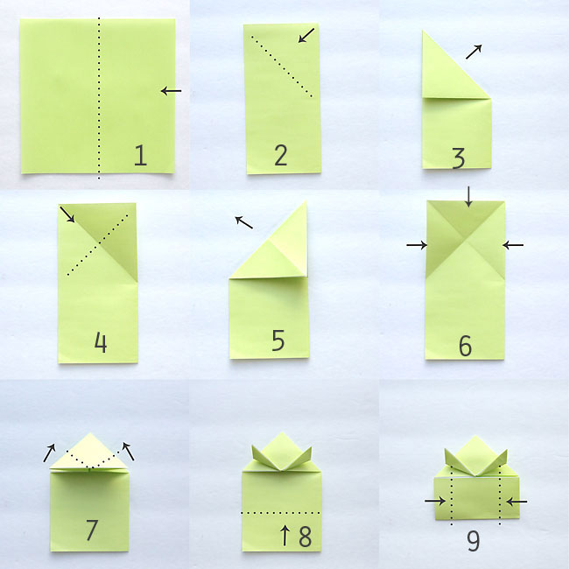

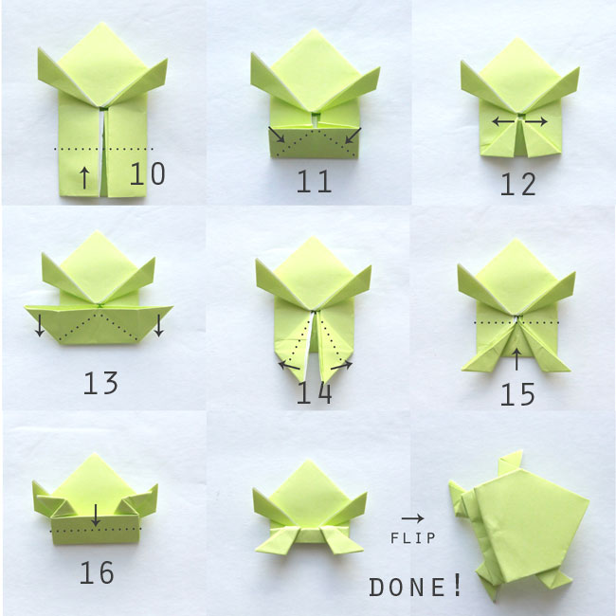

https://www.itsalwaysautumn.com/origami-jumping-frogs-easy-folding-instructions.html

