Home made Larva lamp
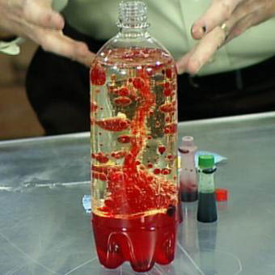

You will need:

A clear plastic bottle, (we used 1 litre, but you could use any clear drink bottle.)
Water
Oil
Food colouring
Alka-Seltzer Tablets

Fill the bottle just over 1/2 full with vegetable oil, then fill the rest of the way with water, leaving an inch of room at the top. Add 10 drops food colouring. Place the bottle on a plate or pie tin to catch any drips. Now, add 1/4 a Alka-Seltzer tablet and watch the bubbles of water rise up through the oil. Add another piece of Alka-Seltzer after the bubbles have stopped.

This kept both kids quite entertained for the afternoon. Harriet wanted to make more of them but I didn't want to use up all my cooking oil. She went through about half a box of the tablets, then we put the lid on when we were done and she used the other half the next day. You could also add some glitter to the water to sparkle it up a bit!

Posted by calico cat at 9:56 AM
Labels: kids

