Frozen Dinosaur Eggs

What you will need:

- Mini alien figures (there are good ones on Baker Ross)
- Water
- Glitter
- Balloons

Method:
1 – Pop an alien figure into the balloon.
2 – Carefully fill the balloon with water and tie the top.
3 – Make sure they retain their egg shape.
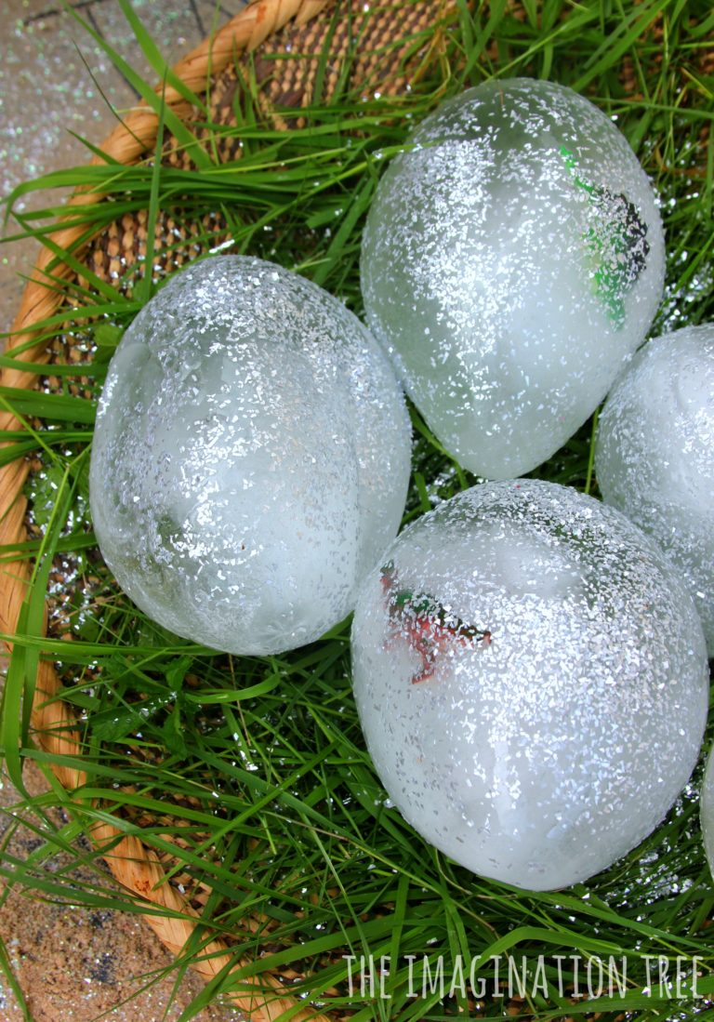
4 – Place the balloon into the freezer.
5 – Wait until they are solid and peel the balloon away.
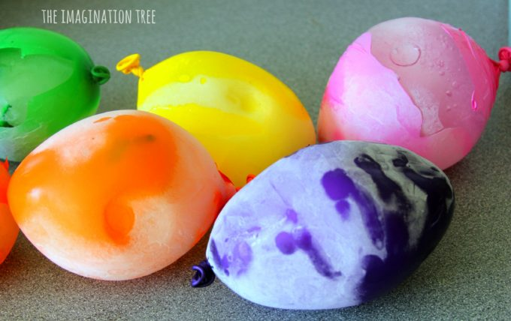
6 – Sprinkle each one liberally with glitter until they look truly OUT OF THIS WORLD!

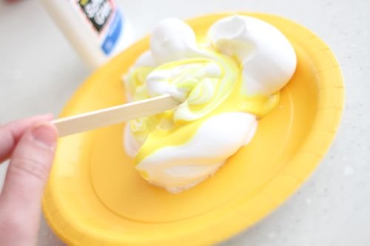
Puffy Planets

What you will need:
- Shaving foam
- PVA glue
- Black poster board
- Food colouring/paint
- Glitter
- Paintbrush
- Neon star stickers

Method
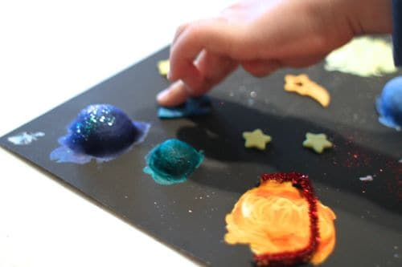
1 – Mix shaving foam with glue. About 3 or 4 parts shaving foam to 1 part glue.
2 – Mix in the colours with a craft stick.
3 – Place the mixture onto the black poster board in the shape of a planet.
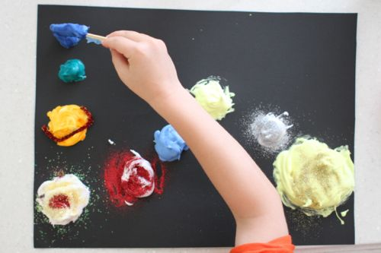
4 – Repeat with different colours until you have your own solar system.
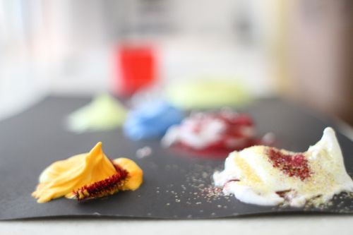

Solar System Snow Globe
What you will need:
- Old jars, new jars, kilner jars
- Plastic space figurine i.e. rocket, alien, planets
- Glycerine (can be subbed for corn syrup)
- Glitter
- Food colouring
- Plastic stars or just about any other decoration that can stay in water
- Superglue
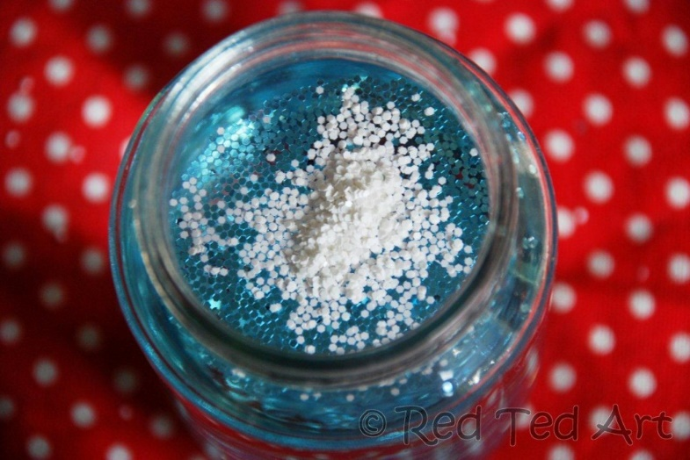
Method

1 – Superglue your figure onto the upturned jar lid.
2 – Fill your jar with water and add a few drops of glycerine/corn syrup.
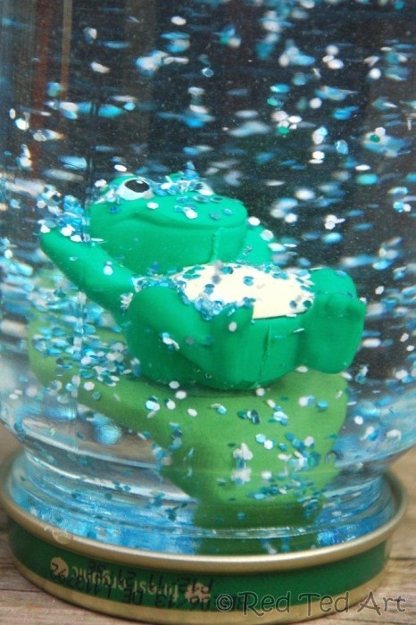
3 – Add glitters, food colourings, mini plastic stars etc
4 – Firmly screw the lid on. Consider gluing it down.
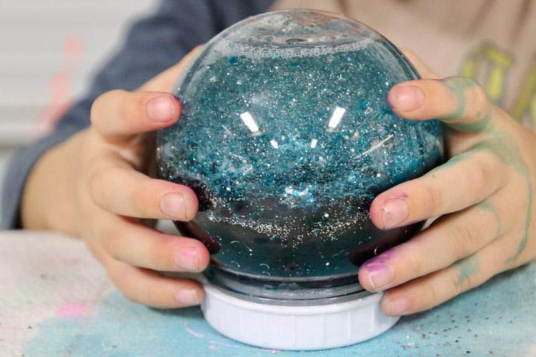
Shake and watch the snow globe magic!
Galaxy Jar
Similar to the last but even prettier!
What you will need:
- Old jar, new jar, kilner jar
- Washable tempera paint (at least 2 colours)
- Cotton balls
- Glitter
Method
- Fill 1/3 of the jar with water
- Add several drops of the paint, put a lid on the jar and shake well to mix the paint and water
- Add a bit of glitter
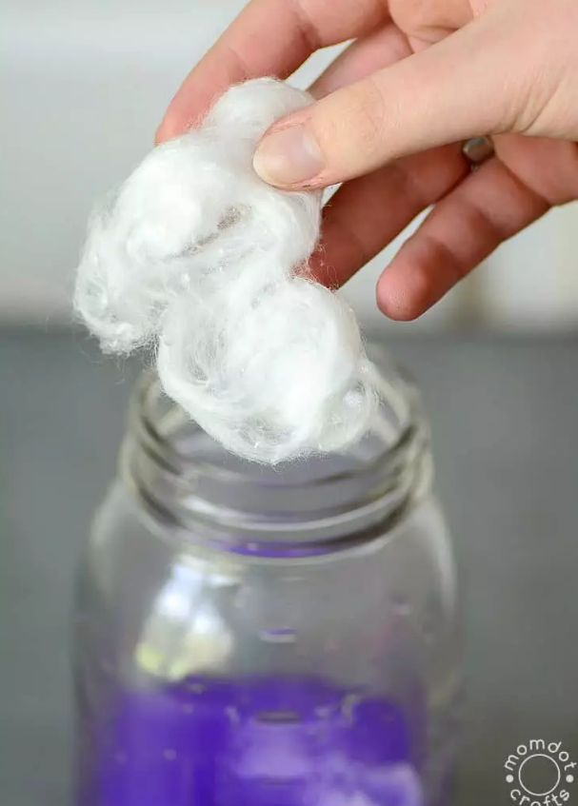
- Stretch out the cotton balls and add until the bottom is filled with cotton balls. Try pressing them down with a stick or knife.
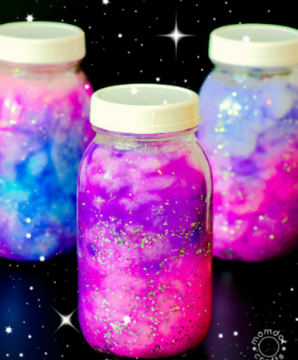
- Repeat steps with varying colours until you have a gorgeous galaxy jar.

Constellation Jar
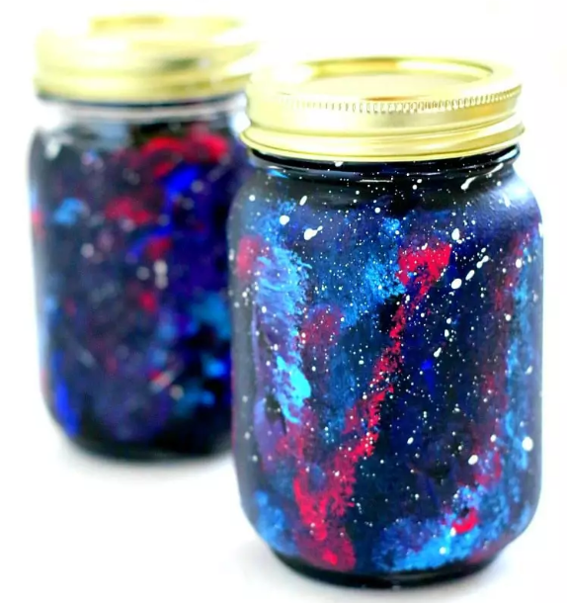
What you will need
- Paint (black, blue, red, purple)
- Glow in the dark paint
- Paint brush
- Paint sponges
- Mason jars

Method
- Paint the outside of the jar entirely black. Leave it to dry.
- Start to sponge on the blues a little at a time smearing and splattering to make a constellation.
- Start to sponge on the pinks and purples in the same way.
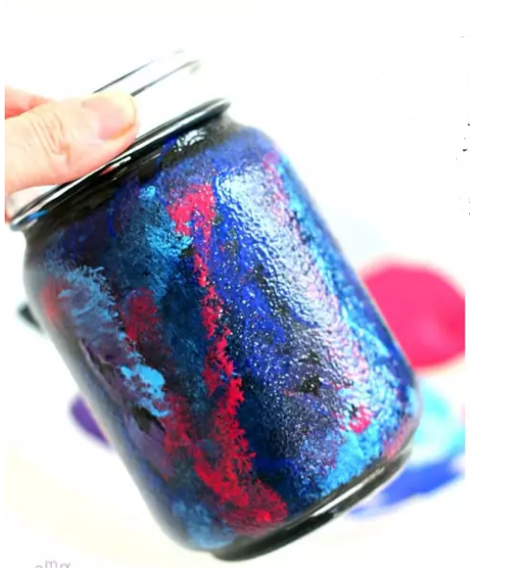
- Add small splatters of white or glow in the dark paint to create the stars.
Display your master piece!

Galaxy Slime
This activity is perfect for creativity and a sensory resource.
What you will need
- Clear School Glue
- Liquid starch
- Liquid watercolors/food colouring
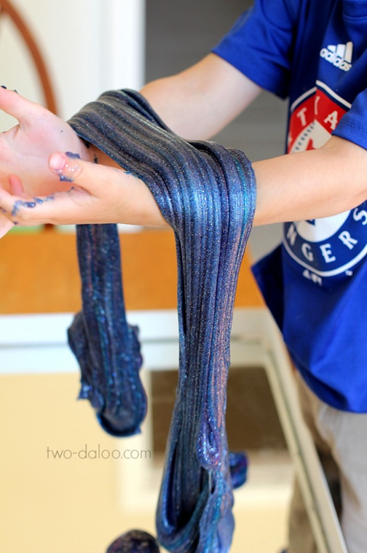
- Fine glitter in a variety of colors

- First bit of advice is TAKE IT SLOW
- Put the glue into a bowl
- Add colours and glitter
- Mix well
- Then add the liquid starch bit by bit. Mix well after each addition until fully incorporated.
- Eventually you will be kneading the starch in to just like making bread dough.
- Keep doing stretch tests after each addition and once the consistency is right… STOP.
Enjoy!
