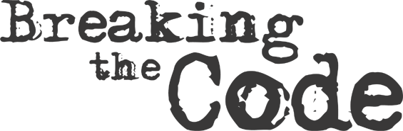

Codes are a way of altering a message so the original meaning is hidden. Generally, this requires a code book or word. Ciphers are processes that are applied to a message to hide or encipher information. These process are reversed to translate or decipher the message. Codes and ciphers form an important part of the science of secure communication (cryptanalysis)

**Method 1**

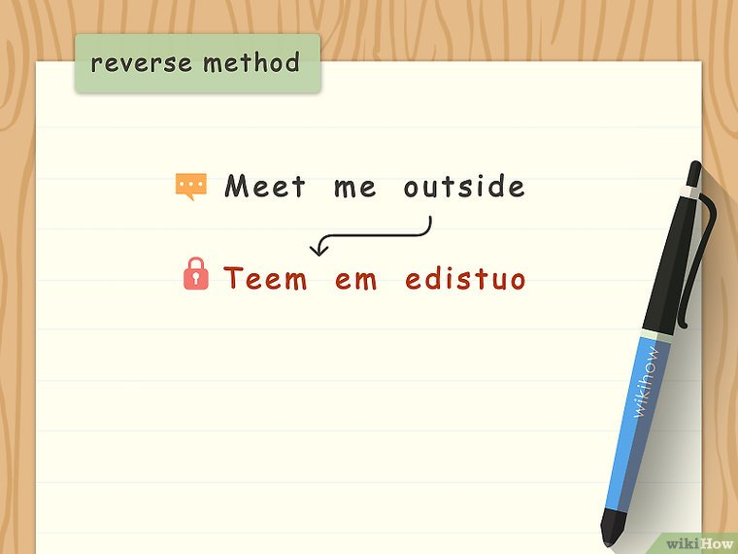

**Write out words in reverse.** This is a simple way of encoding messages so they can't be understood at a glance. A message like "Meet me outside" written in reverse would instead be "Teem em edistuo."

**The reverse method**

**Method 2**

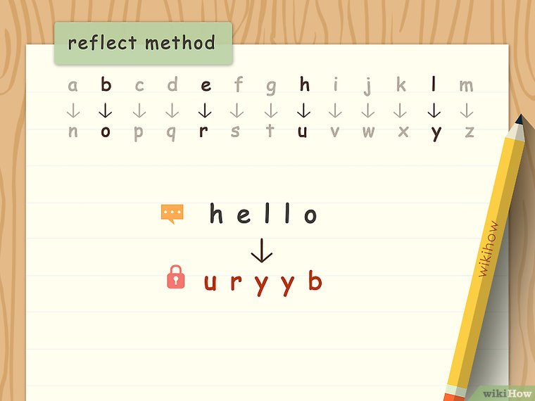

**Reflect the alphabet in half to encipher messages.** Write out the letters A through M in a single line on a piece of paper. Directly beneath this line, write out the letters N through Z also in a single line. Change each letter of messages to the opposite letter of the two lines of letters you have written out.

* By using a reflected alphabet, the message "Hello" would instead become "Uryyb."

**The reverse method**

**Method 3**

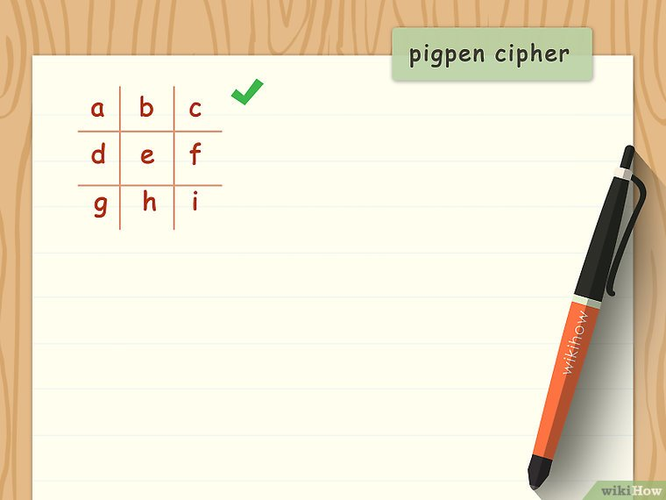

**Try pigpen cipher.** Draw a [tic tac toe](https://www.wikihow.com/Play-Tic-Tac-Toe) grid on a piece of paper. Write out the letters A through I in the grid going from the left to right, top to bottom. In this example:

* The first row is made up of the letters A, B, C.
* The second is made up of D, E, F.
* The last row is made up of G, H, I.

**The Pigeon Method 1**

**Method 4**

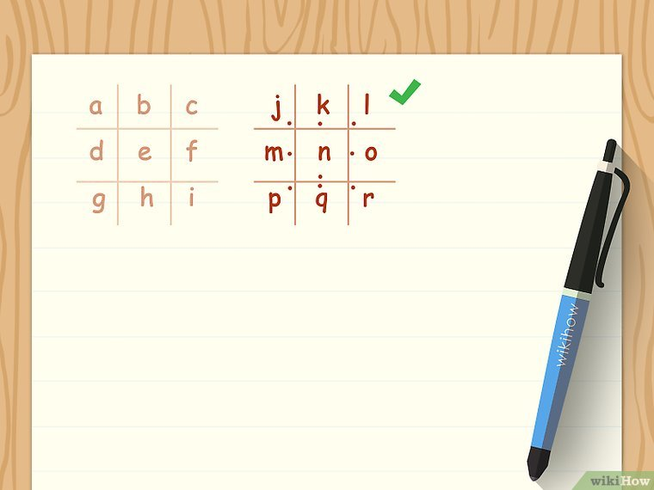

**Create a second tic tac toe grid with dots.** Draw another tic tac toe grid beside the first one. Fill the grid in with the letters J through R, similarly to the first grid. Then mark dots in each space of the grid of each row as described:

* In the first row, starting on the left, place a dot in the lower right corner (letter I), on the bottom middle side (letter K), and in lower left corner (letter L).
* In the second row, starting on the left, place a dot on the middle right side (letter M), on the bottom middle side (letter N), and on the middle left side (letter O).
* In the second row, starting on the left, place a dot in the upper right corner (letter P), on the top middle side (letter Q), and in the upper left corner (letter R).

**Pigeon Cipher 2**

**Method 5**

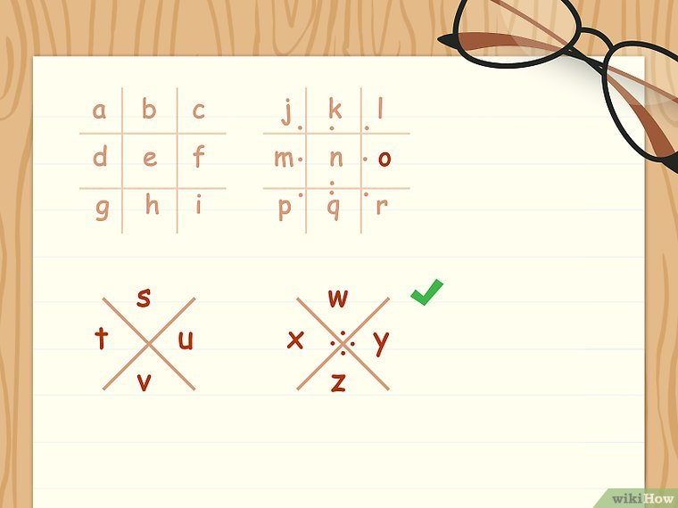

**Write out two X shapes beneath each grid.** These two X shapes will also be filled with letters to complete your pigpen cipher key. In the second X, place dots in the open spaces surrounding where the X crosses so there is a dot on each side of the center of the X. Then:

* In the first (undotted) X shape, write S in the top of the X, T on the left side, U on the right, and V on the bottom.
* In the second X shape, write W in the top of the X, X on the left side, Y on the right, and Z on the bottom.

**Pigeon Cipher 3**

**Method 6**

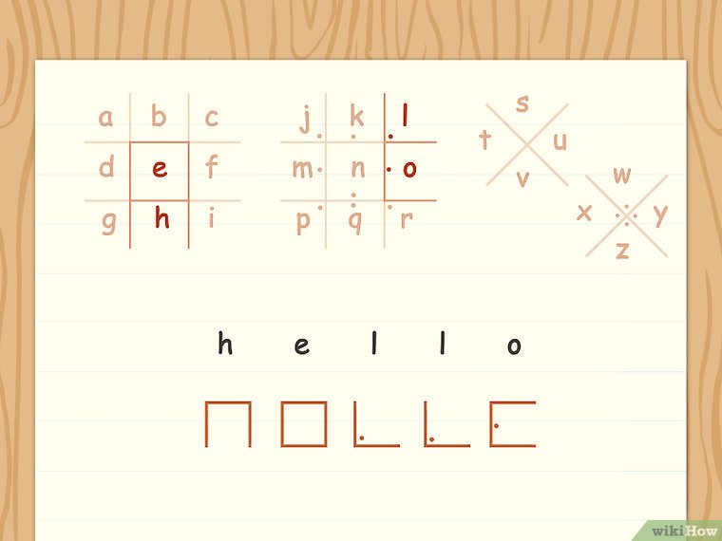

**Use the grid surrounding the letters to write in pigpen cipher.** The grid shapes (including dots) surrounding letters are used as substitutes for the letters themselves. Use your pigpen cipher key to translate messages into and out of pigpen.

**Pigeon Cipher 4**

**Method 7**

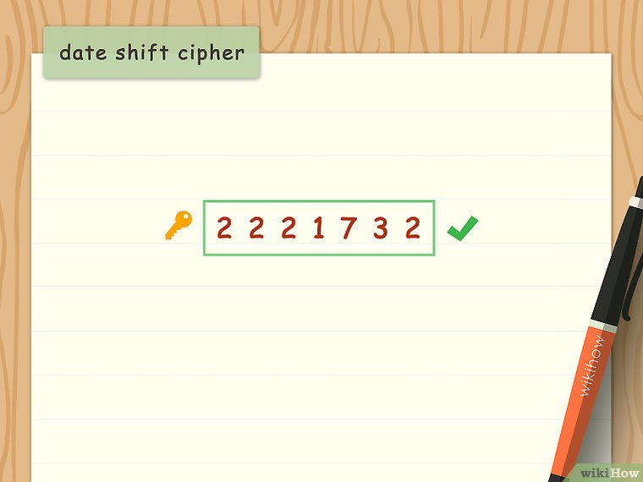

**Use a date shift cipher.** Choose a date. This might be something with personal significance, like a birthday or the day you graduated college, but it could be something impersonal, like the birthday of George Washington. Write out the date as an unbroken string of numbers. This is the number key.

* For example, if you were to use George Washington's birthday (2/22/1732), you would write it as 2221732.
* If you've already agreed to use a date shift cipher with someone, you can accompany enciphered messages with a clue (like “Washington”) for the number key.

**The date shift 3**

**Method 8**

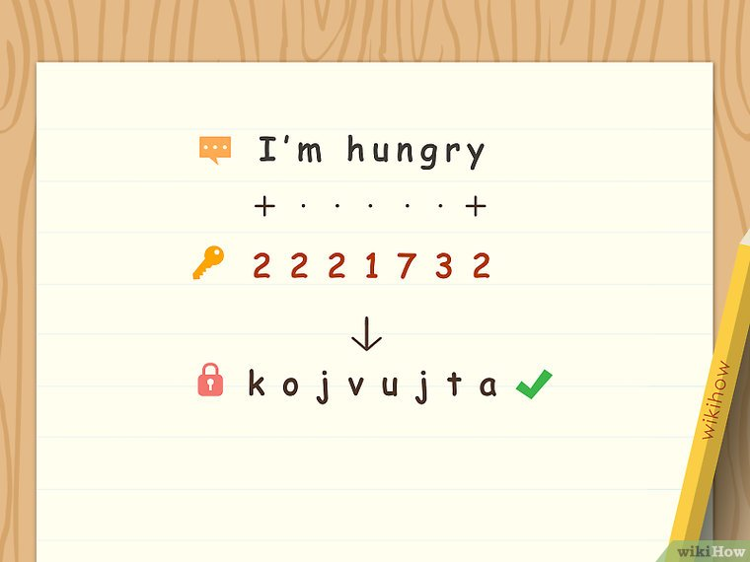

**Encipher your message with the date shift number key.** Write out your message on a piece of paper. Underneath the message, write out a single digit of the number key for each letter of your message. When you reach the last digit of the number key, repeat the key from the beginning. For example, using George Washington's birthday (2/22/1732):

* *Message*: I'm hungry
* *Enciphering*:  
  I.m.h.u.n.g.r.y  
  2.2.2.1.7.3.2.2  
  *Shift letters according to the number key, as in…*
* *Coded message*: K.O.J.V.U.J.T.A

**The Date shift 2**

**Method 9**

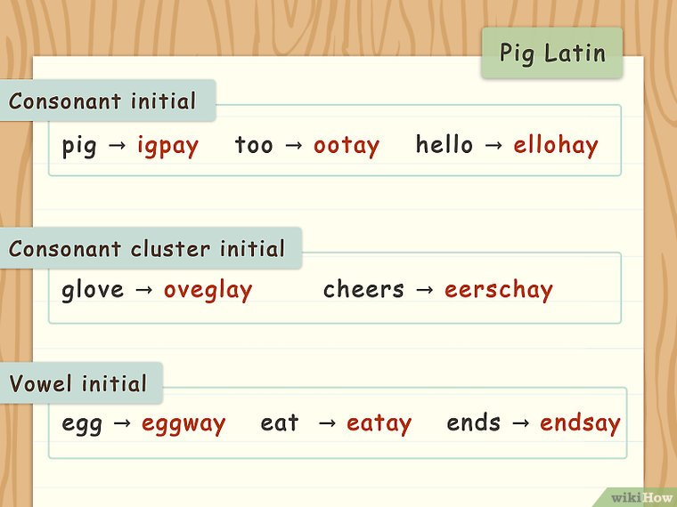

**Use a secret language, like**[**Pig Latin**](https://www.wikihow.com/Speak-Pig-Latin)**.** In Pig Latin, words that start with a consonant sound switch that sound to the end of the word and add “ay.” This holds true for words start with a cluster of consonants. Words that start with vowels just get “way” or “ay” added to the end of the word.

* Consonant initial examples: pig = igpay ; me = emay ; too = ootay ; wet = etway ; hello = ellohay
* Consonant cluster initial examples: glove = oveglay ; shirt = irtshay ; cheers = eerschay
* Vowel initial examples: explain = explainway ; egg = eggway ; ends = endsay ; eat = eatay

**Pig Latin**