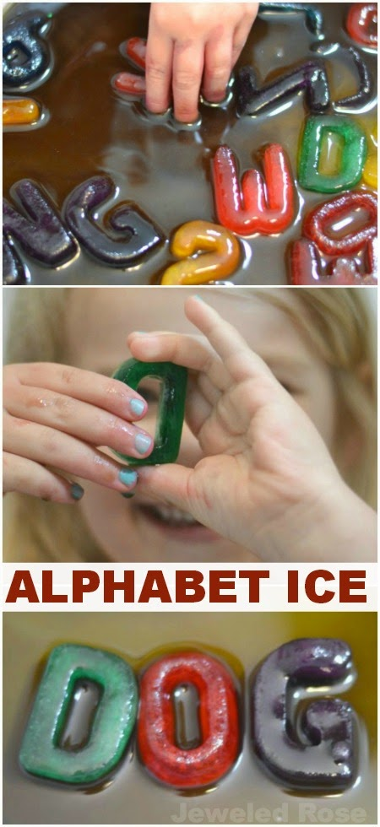
Alphabet Ice

Materials
- Alphabet ice trays
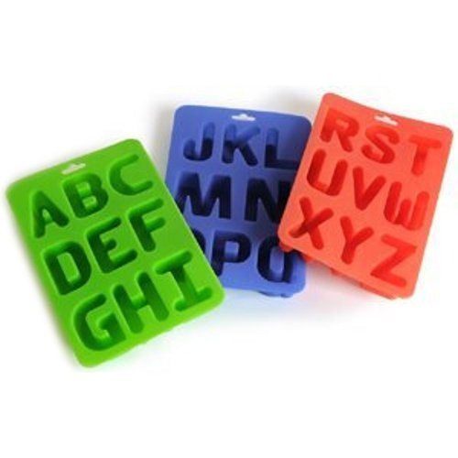
- Kool-aid packets
- Water
Method
If you don't have alphabet ice trays you can get them on Amazon for £10.99. There are lots of fun ways to use these trays, and we have lots more activities using them on the way! To make the Kool-aid ice just sprinkle a little Kool-aid powder into each alphabet slot, fill the trays with water, carefully stir, and freeze. In four to six hours you will have vibrantly coloured and delightfully scented alphabet ice.

